**The CEO**

NIB International Bank S.c. Addis Abeba, Ethiopia

Date: Ref No:

# Subject: Invitation to Join as a Platinum Member of Africa International Skill Hub (AISH)

Dear Mr.Henok Kebede,

We are delighted to invite your esteemed institution to join the **Africa International Skill Hub (AISH)** as a Platinum Member. In partnership with the **Asian African Chamber of Commerce and Industry (AACCI)** and **Beta Technologies**, AISH serves as a dynamic platform for fostering business growth, skill development, and innovation across Africa and Asia.

Through this membership, your institution will gain unparalleled access to cutting-edge resources, strategic connections, and exclusive opportunities to elevate its influence regionally and globally. This partnership is designed to empower your organization while contributing meaningfully to the development of businesses and communities in Ethiopia and beyond.

Enclosed is an exclusive overview of the benefits and services available to Platinum Members. We believe that this partnership will be instrumental in achieving your institution’s strategic objectives and advancing its leadership position in the financial sector.

We would be honored to have NIB International Bank join our network of distinguished members. Please do not hesitate to contact us at +251-953-99-91- 99 OR [info@africaskillhub.com](mailto:info@africaskillhub.com) if you require additional information or wish to proceed with enrollment.

# Sincerely,

Africa International Skill Hub

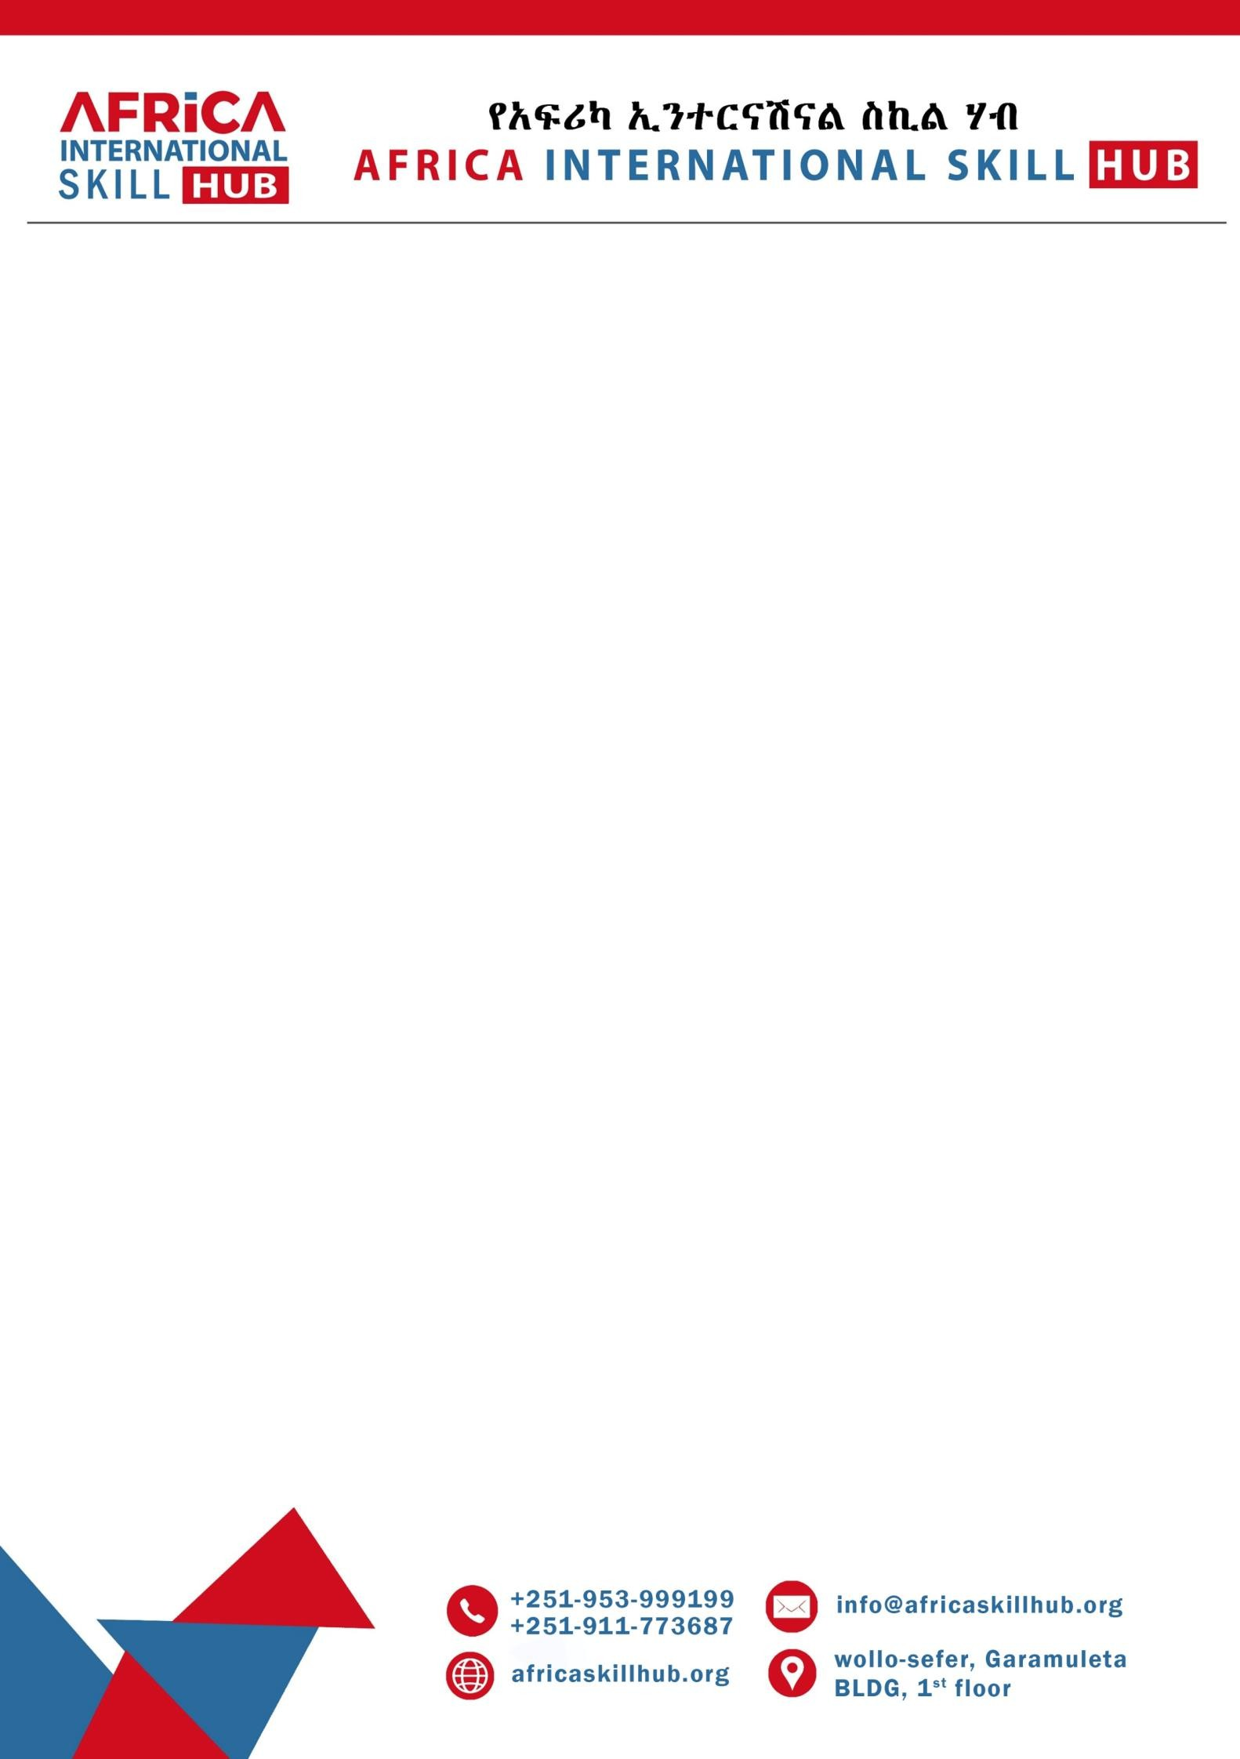

**Enclosure: AISH Platinum Membership Benefits Overview**

# Why Join AISH as a Platinum Member?

In collaboration with the **Asian African Chamber of Commerce and Industry (AACCI)** and **Beta Technologies**, the Africa International Skill Hub (AISH) offers a robust platform designed to support business excellence, innovation, and impactful growth across Africa and Asia.

# Platinum Membership Benefits:

1. **Exclusive Networking Opportunities**
   * Participation in high-level roundtable discussions with global leaders in business, government, and technology.
   * Priority access to trade missions, executive forums, and diplomatic engagements through AACCI.

# Tailored Business Development Support

* + Customized consulting services for market entry, scaling operations, and investment strategies.
  + Access to Beta Technologies’ advanced solutions for operational efficiency

and technological advancement.

* + Technical support for building ecosystems around two key value chains of your choice.

# Global Branding and Visibility

* + Strategic promotion of your brand on AISH, AACCI, and Beta Technologies’

platforms.

* + VIP recognition at international summits, forums, and media campaigns.

# Education and Leadership Programs

* + Executive training programs with leading universities and business schools.
  + Mentorship from global experts affiliated with AACCI and Beta Technologies.
  + Participation in specialized skill-building initiatives and leadership workshops.



# Concierge and Premium Services

* + Comprehensive support for event planning, travel arrangements, and expedited visa processing.
  + Invitations to private business dinners, summits, and galas organized by AISH and AACCI.

# Membership Fee: ETB1,200,000 annually. Conclusion

The Africa International Skill Hub, in partnership with the Asian African Chamber of Commerce and Industry and Beta Technologies, offers your institution a transformative opportunity to lead in your sector, build meaningful partnerships, and access cutting-edge tools for success.

For more information or to confirm your membership, please contact us at +251- 953-99-91-99 OR [info@africaskillhub.com.](mailto:info@africaskillhub.com)

##END.